Coursera Capstone
IBM Applied Data Science Capstone
The Battle of Neighborhoods (Week 1 and 2)

- Liverpool properties analyses –

By Dejan Todorović

INTRODUCTION

-UK is in process of exiting EU, the real estate market is in shake and unpredictable, but now UK facing another problem and that is global pandemic situation.
-In order to assist home buyers in Liverpool to male a good decision of purchase a suitable real estate, we will use our data science powers.
-We will solve this problem by clustering Liverpool neighborhoods so we can recommend venues and the current average price of real estate where buyers can make investment.

DATA

-We will use data for Liverpool properties from UK’s government land registry website https://landeregistry.data.gov.uk/
-The data will be in .csv format. We will also use data from FourSquare API interface, combine two sets of data and arrange data into dataframes (df) and use it for visualization and better understanding.

-After that we will be able to easily recommend profitable real estate for investments.

METHODOLOGY

-In this section we will give 4 stages:
-Collect data
-Inspection data
-Explore and understand data
-Modeling data

-Collect data
– To be able to collect data first we need to import necessary libraries like: numpy, pandas, datatime,json, geopy(with different modules), requests,matplotlib(with different modules),folium,etc. Library geopy will be used to convert an address into latitude and longitude values.
After we import all necessary libraries we need to get data and we use data from http://landregistry.data.gov.uk/ Data is in .csv format so we need to use pandas function .read_csv().

-Inspection data
-After collecting data we need to inspect data and confirm that we have valid data.

-Explore and understand data
-After we fetch data we need to see and try to understand and explore data. We need to put data into panda dataframe first so we can show them. 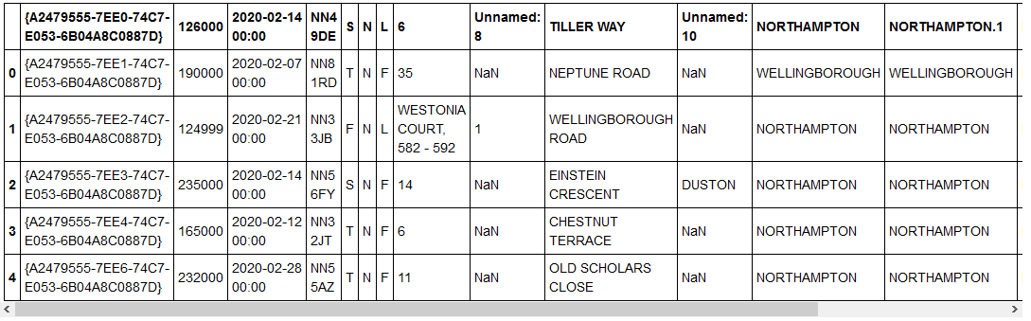

Modeling data -
- We need to set column names, format date column, clean the data, sort data, set customers budget’s max and min limits and finally display data frames whit data.
- We will delete all obsolete transactions from data set which were done before 2019. We will sort data by date of sale. Make list of street names in Liverpool. We will give meaningful names to the columns and set customers budget’s max and min limit. Find location which fits customers budgets. We choose budget between 300000 and 500000.
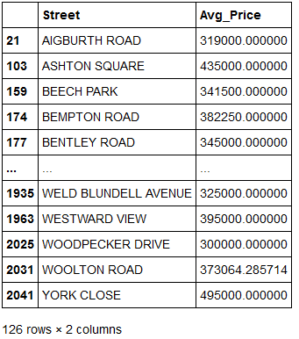

-We will use geopy library. Geopy is Python client. With geopy it is easy to locate the coordinates of addresses, cities, countries across the globe using third-party geocoders and other data sources. So with that we will easily get coordinates from addresses. 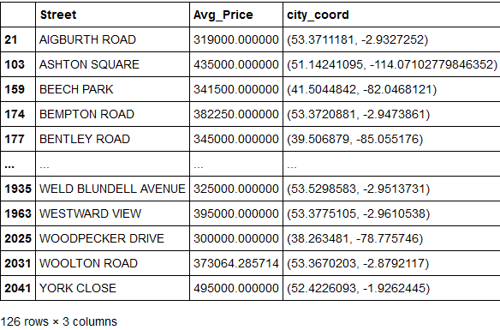
We will tell geopy to take coordinates from Liverpool, UK. After that we will create map of Liverpool and then we will move to FourSqare and combine our data with FourSqare data.

We will use API, add our coordinates and return only relevant information about each nearby venue. Then we will create couple of new data frames. Distribute data in clusters of five. Use k-means clustering and finally create a map.

RESULTS
K-means clustering
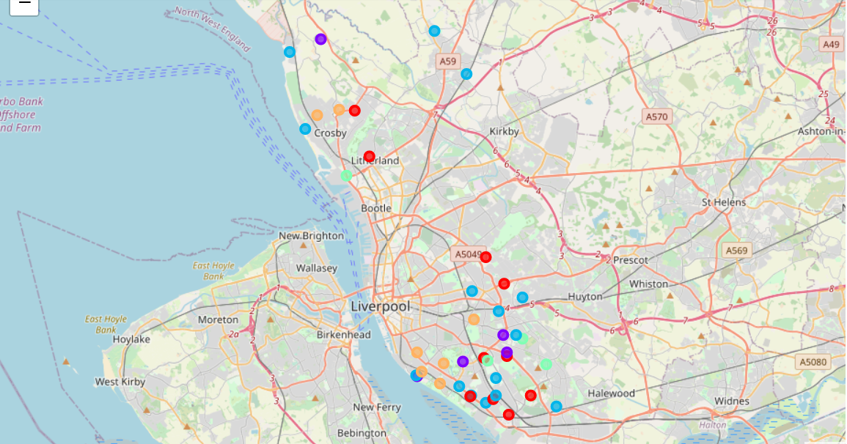
Results on the map are divided in 5 clusters (colors)
For every cluster group we have table with 10 most common venues In that cluster.
Cluster 1 -have low average price of homes and lots of cafes.
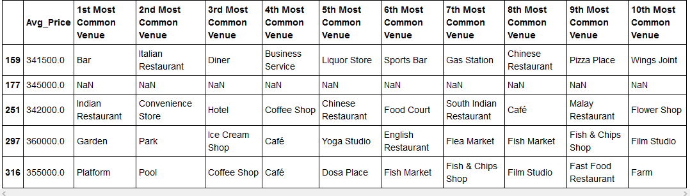
Cluster 2 – have highest average price of homes and have lots of markets and shops
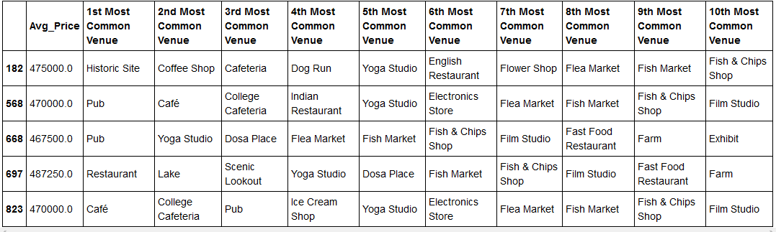
Cluster 3 – have the lowest average price of homes and have lots of restaurants and public transportation options.
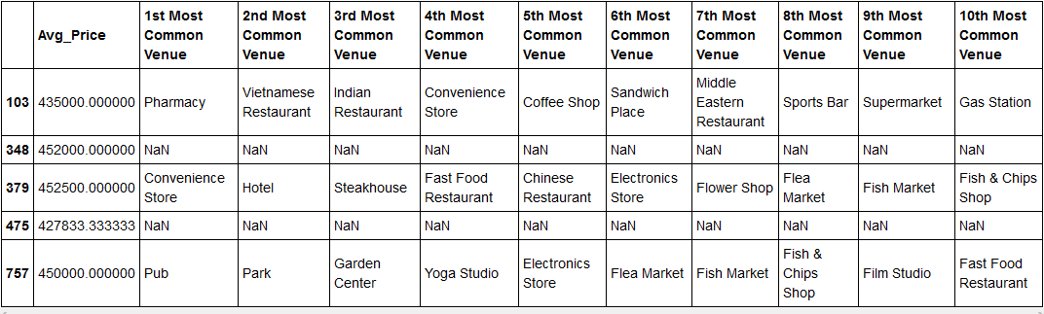

Cluster 4 – have the high average price of homes, have lost of restaurants and shops.
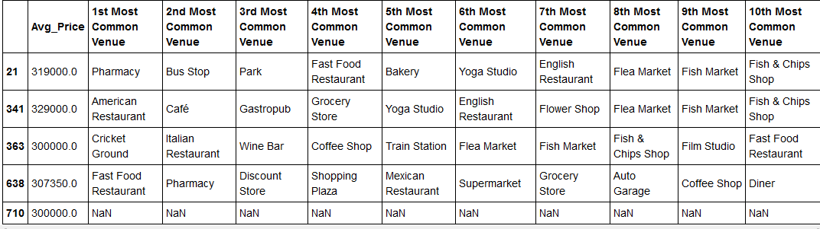

Cluster 5 – have lower average price, have lots of pubs and fast food places.
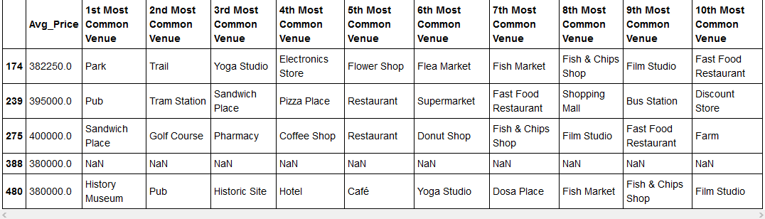

DISCUSSION SECTION
Venues diversity In Liverpool neighborhoods and price of homes are great at the moment.
Clusters 3 and 5 are best place for young people and students.
Clusters 1,2 and 4 are best for families.
Most of properties are situated in south and east part of Liverpool.

LIMITATIONS AND SUGGESTIONS FOR FUTURE RESEARCHES
All of the above analysis is depended on the accuracy of FourSquare data. To get better results, future research work and more comprehensive analysis could consider using a paid account to bypass these limitations as well as incorporating data from other external databases.

CONCLUSION
In this project we have gone through the process of identifying the business problem, specifying data required, extractiong and preparing the data, performing data analysis, and lastly providing recommendations to the house buyers. During the project we applied different data science methods and instruments to get the answer to our main question: “Where In the city of Liverpool, should home buyers invest.

